Product catalog:
A product catalog is a collection of products with their pricing information. The product catalog entities let you create a rich product classification system in Microsoft Dynamics 365.
Make it easier for your sales reps to increase their sales by creating a product catalog. The product catalog is a collection of products and their pricing information. To set up pricing, you need to define the units in which your products are sold, the amount to charge for each unit, and the discounts you want to offer based on volume purchased.
Under the product catalog:
- Product: A product is either a physical inventory item that a company sells. Products from the product catalog can be used to build quotes and orders, and can be associated with opportunities or service cases
- Price lists : A price list contains one to many individual product and bundle prices, aggregated together into a list for categorization purposes
A price list item represents configurations that enable a business unit to control how prices are calculated in Microsoft Dynamics 365 such as quantity selling options, pricing method, rounding policy, and the rounding option
- Discount Lists: Discounts enable a product to have different sales prices; depending on the quantity purchased A discount list is an aggregation of different discounts, specifying how much of a discount the user can receive when the purchasing amount falls between certain ranges. Discount lists can exist at each quantity level, together with detail lines that contain the quantity breakpoints
- Unit Groups. A unit is a measurement that specifies in what quantity a product will be sold
A unit group contains one to many types of unit of measurement, as calculated from a base unit. A product is tied to a unit group in which it is sold.
- Product families : Product families provide a way to group, classify and categorize products for more streamlined product management
Navigation: Settings →Businesses→ product catalog
Set up a product catalog: Walkthrough -- IMP
Because of how units, discounts, and prices are tied together, it’s important that you create each of these components in a product catalog in the following sequence:
Step | Description | Navigation links
 | Create discount lists to offer your products and services at different prices, depending on the quantity purchased. | Set up a discount list
 | Define the measurements or quantities your products will be available in. | Create a unit group and add units to that group
 | Create products for the items you sell. You can create a standalone product or a product inside a family depending on how you want to organize and classify your products. Each product you create will be linked to a unit group and default unit. You can also create a standalone bundle or a bundle inside a product family. | Classify products and bundles into product families
 | Define pricing for your products. | Create price lists and price list items to define pricing of products
 | Add price list items. A price list item defines the price per unit of a product. Add each new product to one or more price lists as price list items. You can do this either from the product form or the price list form. | Classify products and bundles into product families  - OR -  Create price lists and price list items to define pricing of products
 | Select one of the price lists to which you added the product as the default price list for the product. Microsoft Dynamics 365 uses the default price list for calculations when the associated price list in the opportunity or order for the product doesn’t contain a price definition of the product. | Classify products and bundles into product families

Settings :
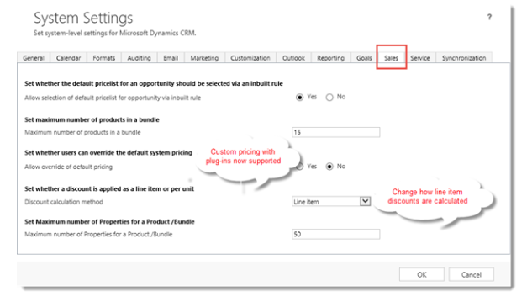

Opportunity :

Prepare Data for an Opportunity

The opportunity entity represents a potential sale to new or established customers.
Before you create an opportunity, ensure that Microsoft Dynamics 365 contains necessary data:
- Create accounts, contacts, and leads before you create an opportunity. You can create an opportunity for an existing account or contact, or convert a qualified lead into an opportunity.
- Each opportunity must be associated with one account or a contact.
- Qualify a lead for an opportunity by using your company’s lead qualification criteria. The possible states for a lead are Open, Qualified, and Disqualified.
If you add products to an opportunity, the system must contain a product catalog, products, price lists, and units of measure.
You can create an opportunity from a qualified lead or you can create a new opportunity for one of your existing customer
Is it possible to create a quote, order and Invoice?
If an opportunity is won, you may convert it to a quote, or to a sales order or an invoice
Ans: by Clicking reopen opportunity
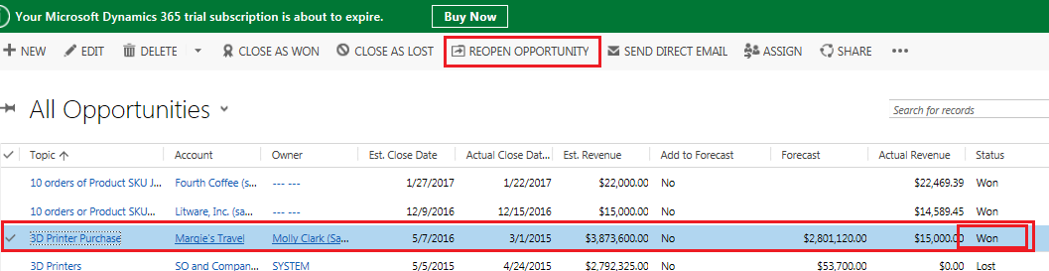
How many ways can we create opportunities?

Creating New Opportunities
New opportunities can be created the following ways.

A. From the command bar in the Opportunities section
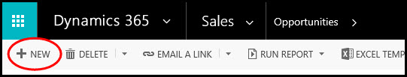
View creating a new opportunity in CRM 2011

B. Converting a tracked email from Outlook
1. in email, click on Track in the ribbon. Doing this will activate the Convert to button.
2. Click on Convert to > Opportunity
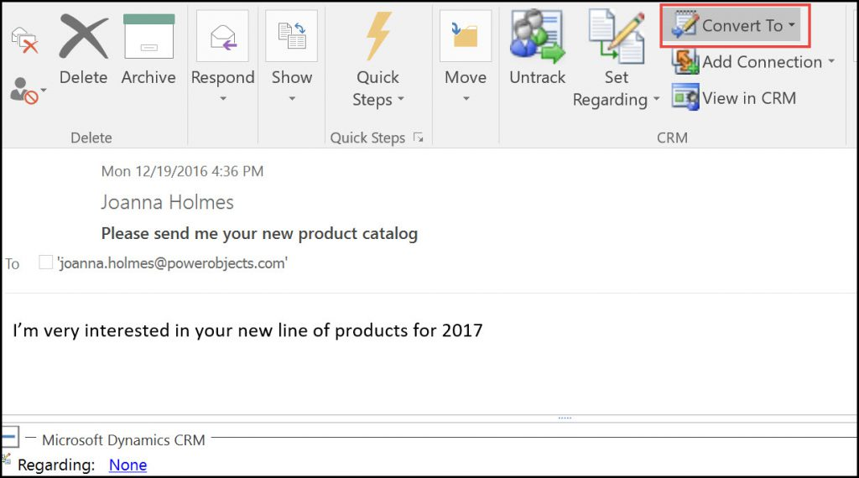
3. Click on the customer look up and select the appropriate customer.
4. Complete filling out the opportunity as usual.

C. Converting a CRM activity
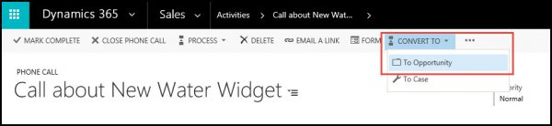
View converting an activity in CRM 2011

D. Qualifying a Lead
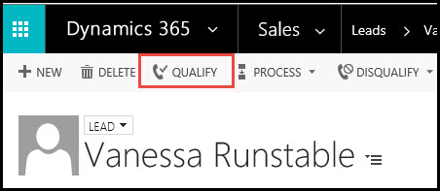
View qualifying a lead in CRM 2011

E. Converting campaign responses
1. In the top navigation of a campaign response record, click the Convert Campaign Response button. A new window will open.
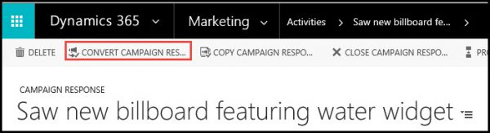
View converting a campaign response in CRM 2011
2. Select the “Create a quote, order, or opportunity for an account or contact” radio button.
3. Look up the account, select the opportunity option, and set a currency.
4. Click Ok.

